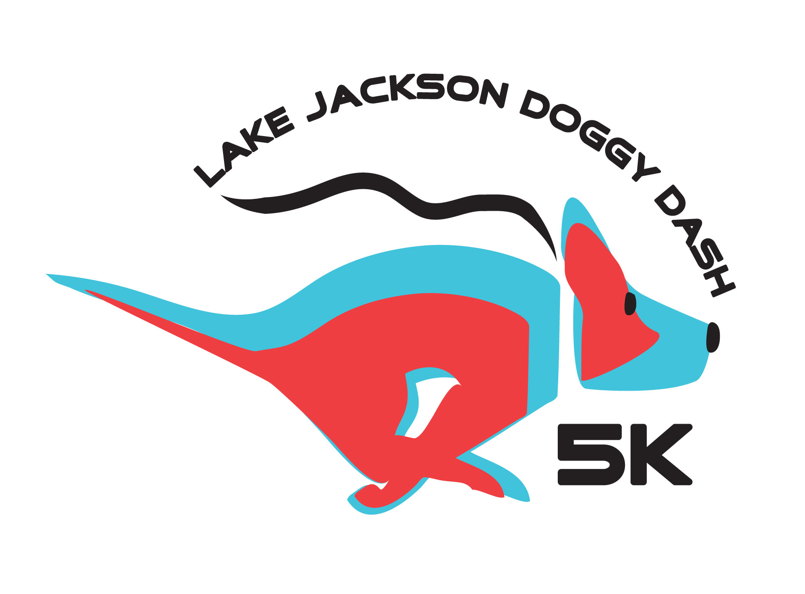
LJ DOGGY DASH 5K &
BARK IN THE PARK
SPONSORSHIP LEVELS

- TITLE SPONSOR ($2,000)
  - Sponsor’s name in Event Title – “(The Title Sponsor) Presents the 2019 Lake Jackson Doggy Dash and Bark in the Park Event”
  - All items in the TOP DOG sponsorship, PLUS
  - Sponsor’s name or logo printed on the T-shirt (Large across top of shirt)
  - Prominent place of your exhibitor booth (company provided table/booth)
  - Business featured on Facebook

- TOP DOG SPONSORS ($1,000 OR MORE)
  - All items in the FANTASTIC FIDOS sponsorship, PLUS;
  - Sponsors name or logo printed on the event t-shirt (Large Size)
  - Highlighted in all event marketing including event brochure and poster
- Inclusion of your promotional items in the event gift bag
  - Prime placement of your exhibitor booth (company provided table/booth)
  - Banner hung at the event (company supplied)

- FANTASTIC FIDOS SPONSORS ($500-$999)
  - All items in the REMARKABLE ROVERS sponsorship, PLUS;
  - Sponsor’s name or logo listed on the LJ Doggy Dash website sponsor page (Including link to Sponsor’s website)
  - Sponsor’s name or logo printed on the event t-shirt (Medium Size/Font)

- REMARKABLE ROVERS SPONSORS ($250-$499)
  - All items of the MEMORABLE MUTTS sponsorship PLUS;
  - A link to the Sponsor’s website from the LJ Doggy Dash website sponsor page
  - Sponsor’s name or logo printed on the event T-shirt (Small Size/Font)

- MEMORABLE MUTTS SPONSORS ($250)
  - Sponsor’s name listed on the LJ Doggy Dash website sponsor page
  - Free event T-Shirt for the Sponsor
  - Sponsor’s name in all event marketing including brochure and poster
  - Sponsor’s name printed on the event T-Shirts (name listed)
  - An exhibitor booth at event (company provided table/booth)
____________________________________________________________________________
Sponsor’s Name (please print):________________________________________________
Sponsor’s Address: _________________________________________________________
Sponsor’s Phone:___________________________________________________________
Sponsor’s Email: ___________________________________________________________
Business Website URL:______________________________________________________

Amount of Donation: ________________________
T-shirt Size: Sm Med Lrg X-Lrg
NOTE: If donations are made AFTER February 8th, 2019, sponsor logo will be recognized with the exemption of the t-shirt.

